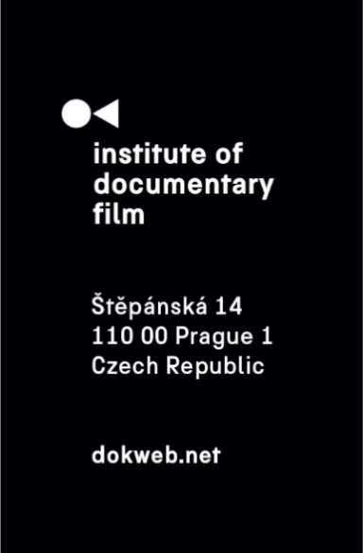
Press Release, Jihlava, October 30, 2021

Silver Eye Award 2021 goes to Mara and Sounds of Weariness
Silver Eye Award 2021 for best feature documentary of the East Silver Market, given by the Institute of Documentary Film at Ji.hlava IDFF, went to Mara by Sasha Kulak. Orpheus by Vadim Kostrov got Special Mention. The winner of short documentary category is Sounds of Weariness by Taymour Boulos.
Rebecca De Pas (Visions du Réel), Maarten Stoltz (Movies That Matter) and Cintia Gil (film curator) have decided about the winner in a feature length category: „The jury has unanimously decided to award a film that elaborates Mythology to confront an urgent political context with bravery unifying the fight for freedom and the constitution of beauty. The Silver Eye Award for feature length documentary film goes to Mara by Sasha Kulak.“
The jurors have decided to give the Special Mention to Orpheus by Vadim Kostrov for seeing the risk of experiencing with life and filmmaking in modern Russia.
Marija Milovanović (Vienna Independent Shorts), Lenka Tyrpáková (Pragueshorts Film Festival) and Emilia Mazik (Short Waves Festival) explained their choice in short category: "We’re awarding the film that reminds us of the importance of having public spaces, which serve as a meeting hub for human interaction where you can share your own experiences and ideas with others. An intimate and personal reflection is told in a subtle way, adding to the contemporary discussion about migration and mental health issues. The winning film's aesthetic of using a floating camera helps to create an overall outstanding audiovisual piece. Without further ado, the Silver Eye Award for Best Short Documentary Film goes to Sounds of Weariness by Taymour Boulos."
The winner in each category received not only a unique award designed by Zdeněk Durdil, but also a prize money of 2 500 €, and along with the winner of Special Mention also a year-long festival service of the East Silver Caravan worth of additional 3 500 €.
Silver Eye Award 2021 nominees – feature length documentaries:
Colors of Tobi (dir. Alexa Bakony, prod. Gábor Osváth, Ildikó Szűcs, Hungary, 2021, 81')
Disturbed Earth (dir. Kumjana Novakova, Guillermo Carreras-Candi, prod. Guillermo Carreras-Candi, Spain, Bosnia and Herzegovina, North Macedonia, 2021, 72')
F@ck This Job (dir. Vera Krichevskaya, prod. Mike Lerner, Vera Krichevskaya /Six Days Film/, United Kingdom, Russia, Germany, 2021, 104')
Hippodrome (dir. Vladimir Loginov, prod. Elina Litvinova, Pille Rünk /Allfilm/, Estonia, 2021, 85')
Landscapes of Resistance (dir. Marta Popivoda, prod. Dragana Jovovic /THEORY AT WORK/, Jasmina Sijercic /Bocalupo Films/, Serbia, Germany, France, 2021, 95')
Lines (dir. Barbora Sliepková, prod. Barbara Janišová Feglová /HITCHHIKER Cinema/, Slovakia, 2021, 80')
Mara (dir. Sasha Kulak, prod. Louis Beaudemont /Les Steppes Productions/, Ksenia Gorenstein, France, United Kingdom, 2021, 62')
Orpheus (dir. Vadim Kostrov, prod. Gleb Piryatinskiy /mal de mer films/, Russia, 2021, 116')
Roses. Film - Cabaret (dir. Irena Stetsenko, prod. Oleksandra Kravchenko, Oleg Sosnov, Ukraine, 2021, 80')
Intensive Life Unit (dir. Adéla Komrzý, prod. Pavla Janoušková Kubečková /nutprodukce/, Czech Republic, 2021, 72')
Feature length documentaries jury:
Rebecca De Pas (Visions du Réel, Programmer)
Maarten Stoltz (Movies That Matter, Programmer)
Cintia Gil (Film Curator)
Silver Eye Award 2021 nominees – short documentaries:
Dirndlschuld (dir. Wilbirg Brainin-Donnenberg, prod. Wilbirg Brainin-Donnenberg, Austria, 2021, 15')
Don’t Hesitate to Come for a Visit, Mom (dir. Anna Artemyeva, prod. Daphne Pascual, Russia, 2021, 12')
Dusk (dir. Bálint Bíró, prod. Bálint Bíró, Hungary, 2020, 21')
For Tomorrow Paradise Arrives (dir. Anna Hints, prod. Evelin Penttilä /Stellar Film/, Johanna Maria Paulson, Estonia, 2021, 28')
Children of the Dead (dir. Luay Albasha, prod. Luay Albasha, Dominik Barič, Spain, Czech Republic, 2021, 24')
I'm Here (dir. Julia Orlik, prod. Agata Golańska, Poland, 2021, 15')
Once Upon a Time in Israel (dir. Weronika Szyma, prod. Weronika Szyma, Poland, 2021, 11')
Solar Voyage (dir. Adam Zadlo, prod. Jerzy Kapuscinski & Ewa Jastrzebska /Munk Studio – Polish Filmmakers Association/, Poland, 2021, 18')
Sounds of Weariness (dir. Taymour Boulos, prod. Taymour Boulos, Lebanon, Belgium, Hungary, Portugal, 2021, 13')
WE HAVE TO SURVIVE: Fukushima! (dir. & prod. Tomáš Krupa /HAILSTONE/, Slovakia, 2021, 13')
Short documentaries jury:
Marija Milovanović (Vienna Independent Shorts, Head of International Competition Fiction & Documentary)
Lenka Tyrpáková (Pragueshorts Film Festival, Programmer)
Emilia Mazik (Short Waves Festival, Festival Director)
Contact:
Veronika Zýková
PR Manager
zykova@dokweb.net
+420 736 116 013

